**Develop a Python Script**

**Publish Data to the IBM Cloud**

|  |  |
| --- | --- |
| Team ID | PNT2022TMID537346 |
| Project Name | Project Name - Signs with Smart Connectivity for better Road Safety. |
| Mentor | Anupama j Nair |

**STEPS INVOLVED**

**Step-1: Create a device in IBM Watson:**

* Firstly, login into your IBM-Bluemix account with your e-mail ID and Password.

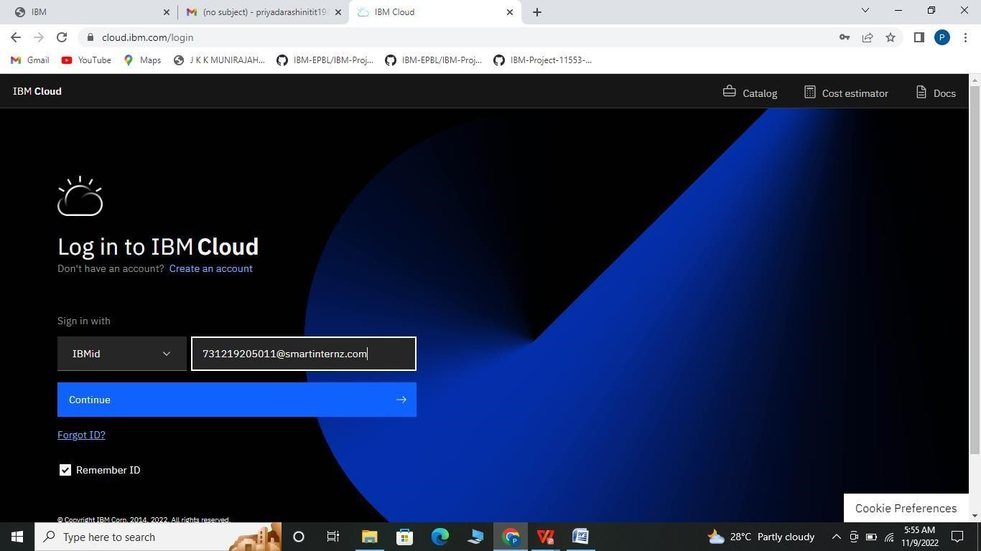

* Click on catalog on your dashboard screen

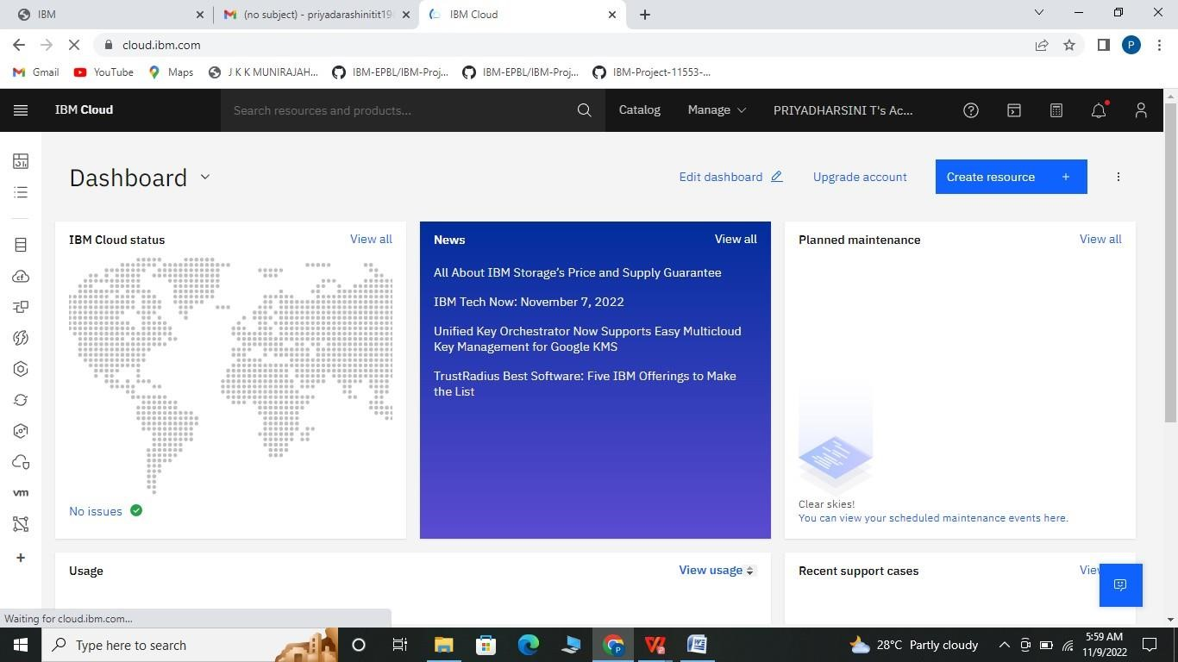

* Under Platforms Go to Internet of Things.

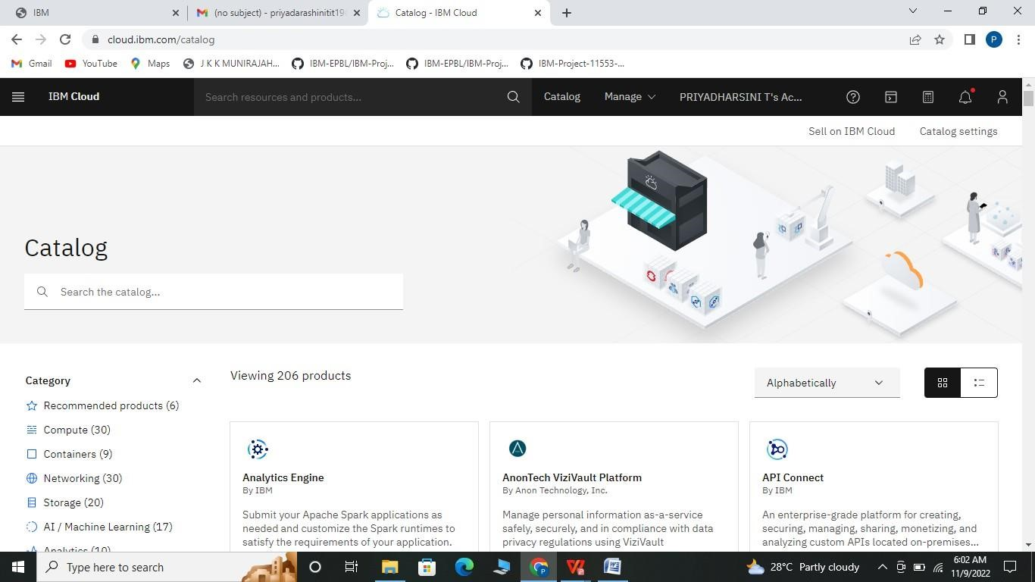

* Under Internet of Things Internet of Things Platform

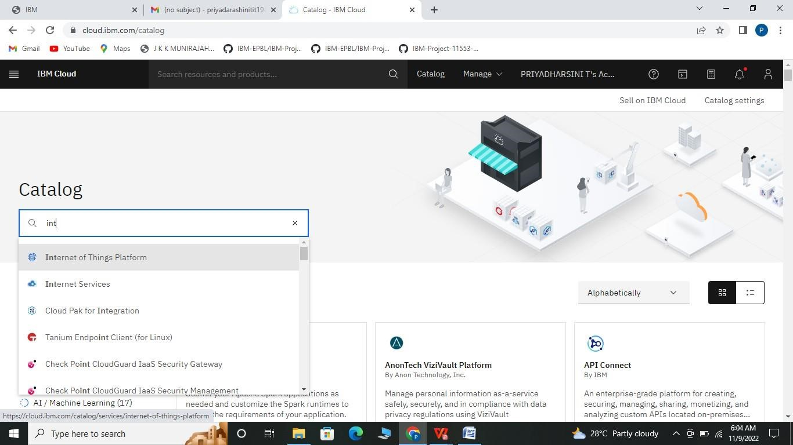

* Then give a name for your Service name and click on Create

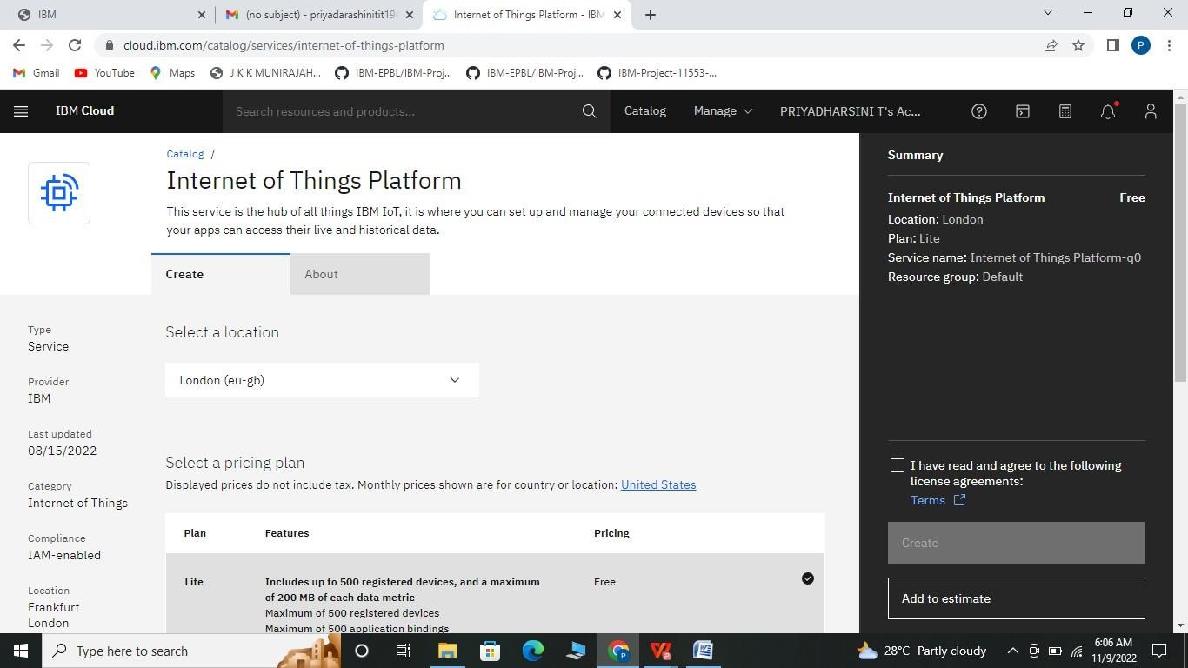

* After getting into your service click on Launch

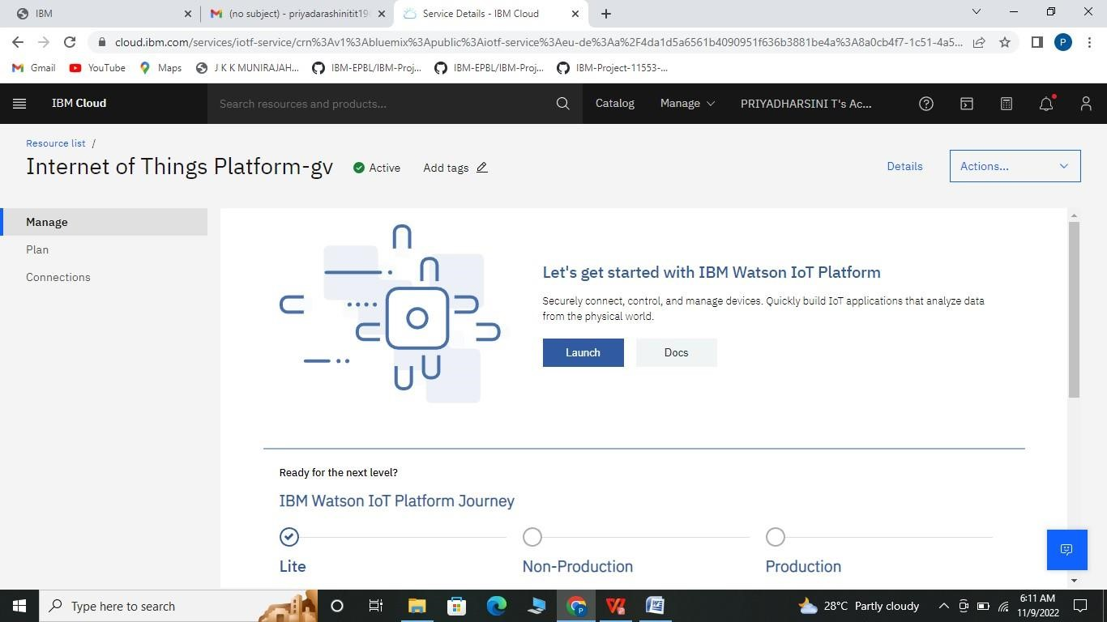

* Then you get into IBM Watson Platform .Then click on Devices

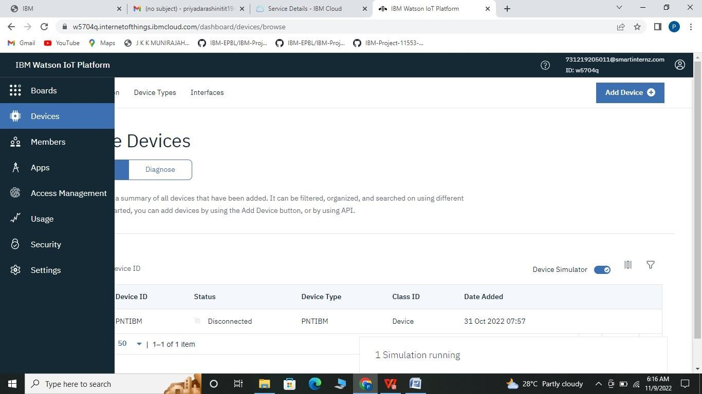

* When you get into Devices you find a button called +Add Device click on it.

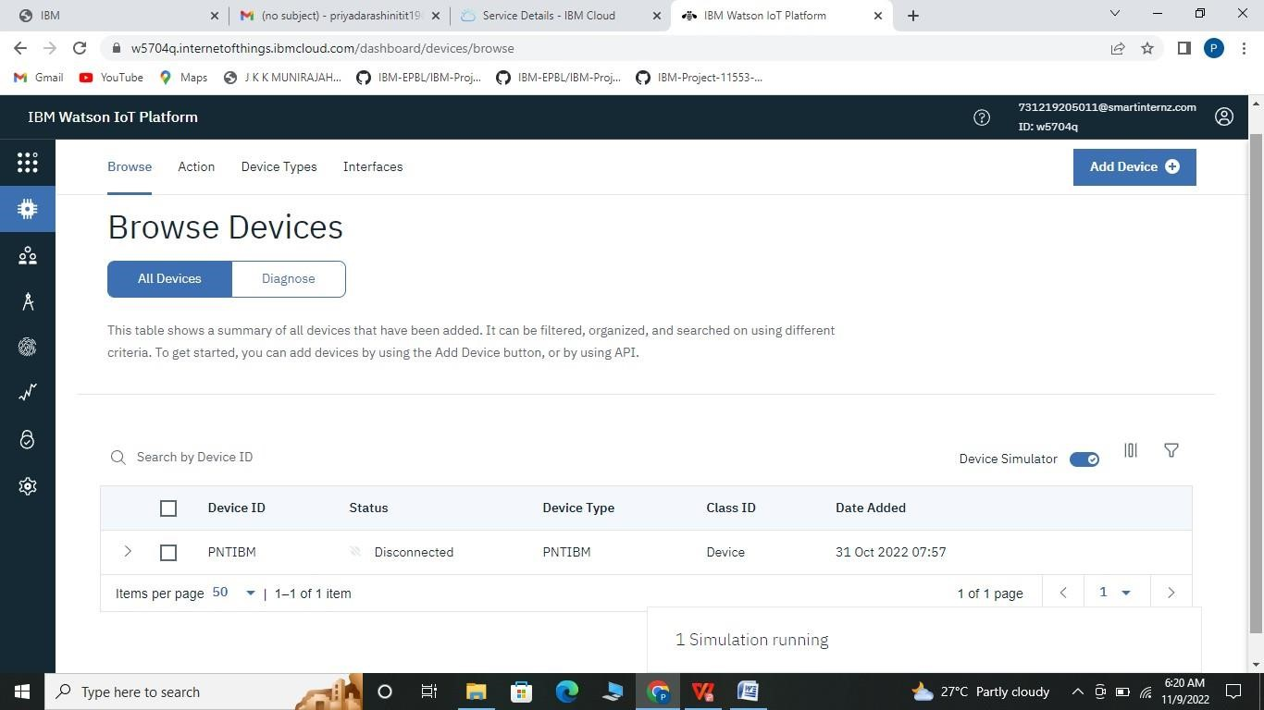

* If successfully created Device Then Finally you get your device Credentials which you can use later. Copy them and paste them in a notepad for future uses.

**STEP-2: INSTALLING NECESSARY PACKAGES ON YOUR PI:**

* Now we are going to install necessary packages on your pi.
* Open your terminal in your pi and type the following commands
* curl -LO https://github.com/ibm-messaging/iot- raspberrypi/releases/download/1.0.2.1/io t_1.0-2_armhf.deb
* sudo dpkg -i iot_1.0-2_armhf.deb service iot status Following are the images as to what appears on your pi’s terminal when u type these commands:

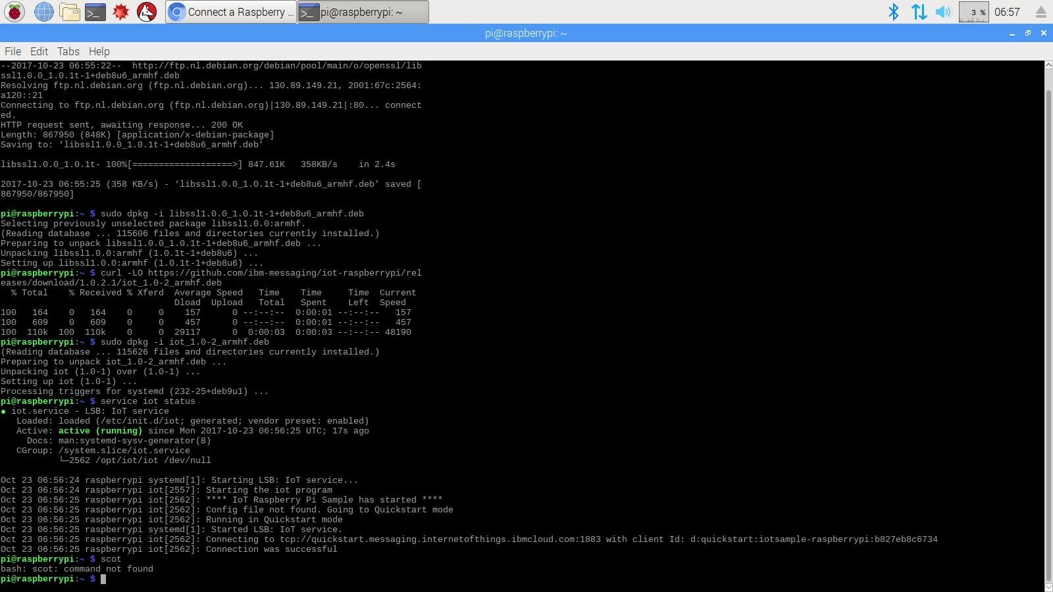

* Then open your terminal and type pip install ibmiotf

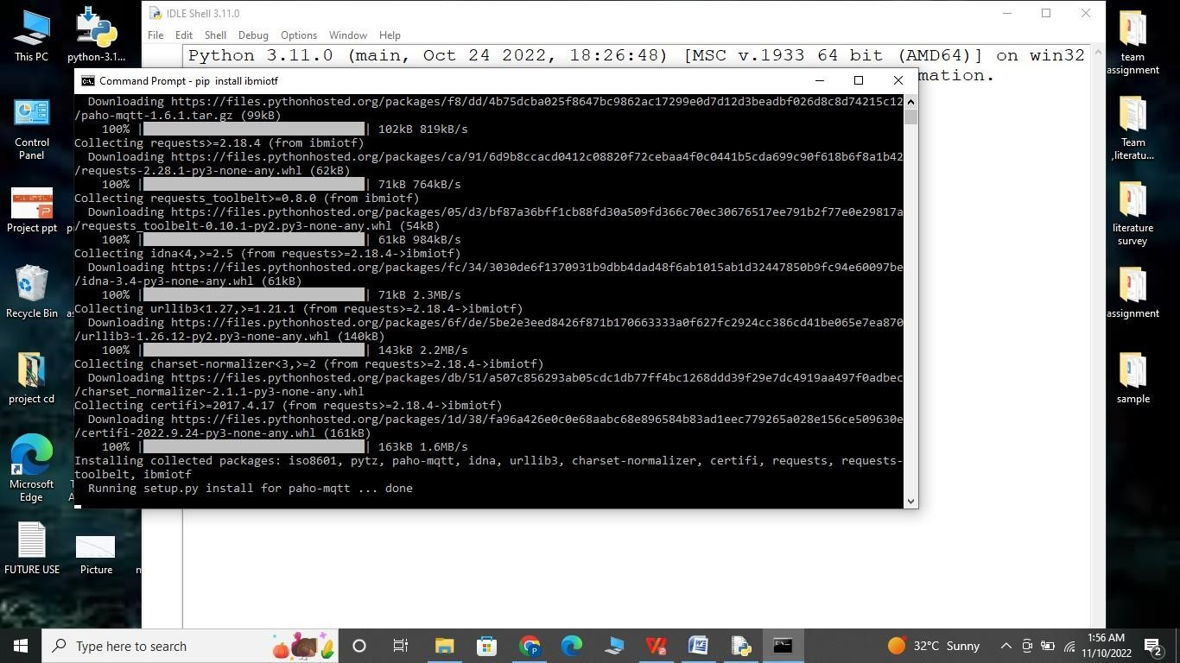

* I have sent DHT-11 Sensors data to ibm bluemix .To get the code u need to login into IOT GYAN.
* Then I get the image as follows in my pi’s shell:

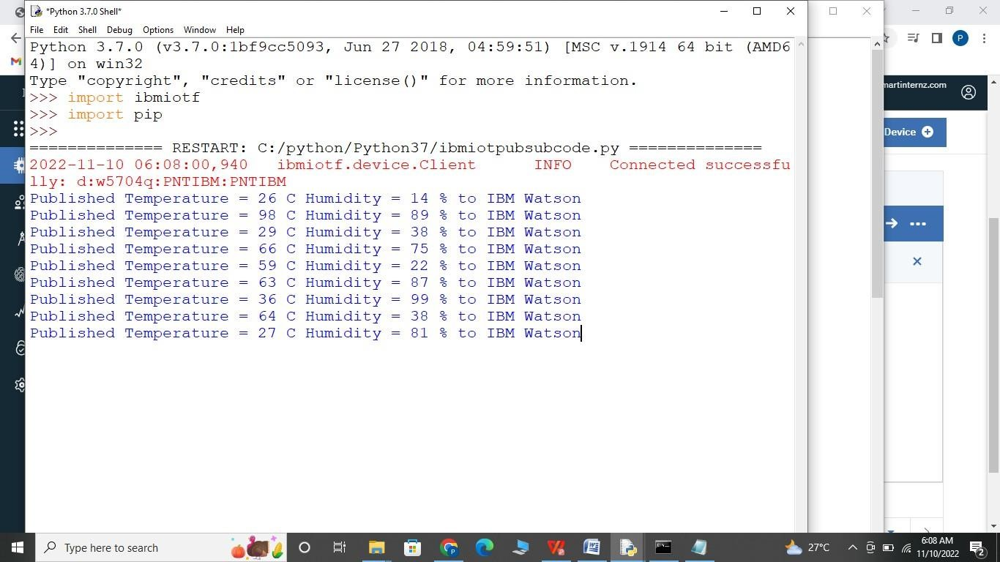

**Step-3: checking your data sent on IBM Bluemix:**

* After you have sent your sensors data you can check whether it is received at your iot platform Just look at the image below and if u see the same wifi kind of symbol on your created device then your dta is being received.



* After double clicking on your created device you can see the received data as shown in image

**Step-4:Creating boards and cards for visualization of data:**

• In your Watson platform you have an option called board. Click on it and you get the following window on your screen

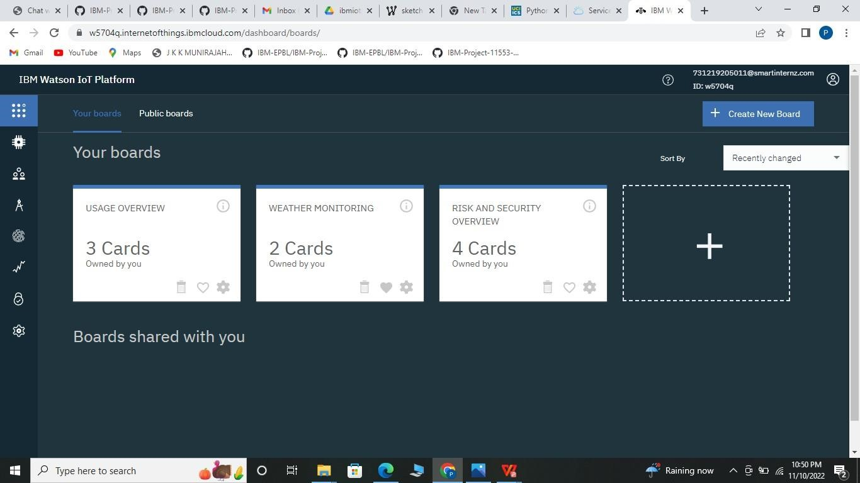

* **Click on Create a new board to create a board .**

The given below window appears give a name and description to your board as shown in the window below

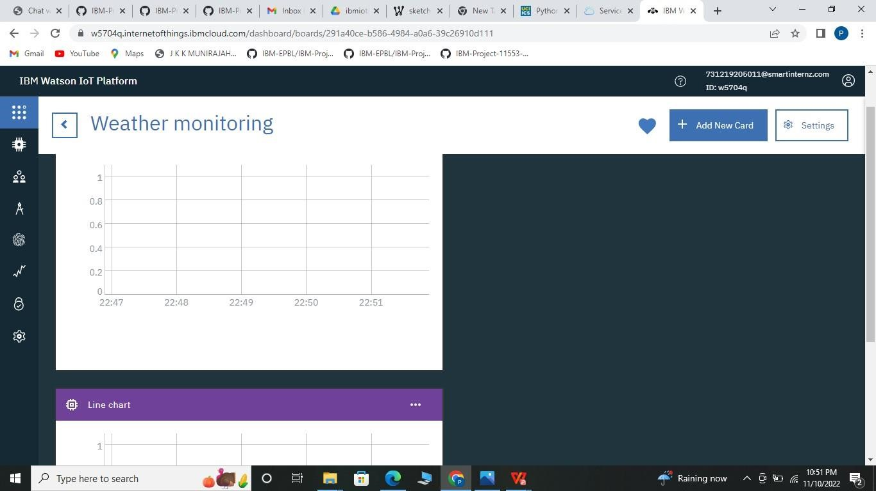

* Then click on Next you get the below window then again click on ADD
* Select the type of Graph u want accordingly and Click next ● You get the below window

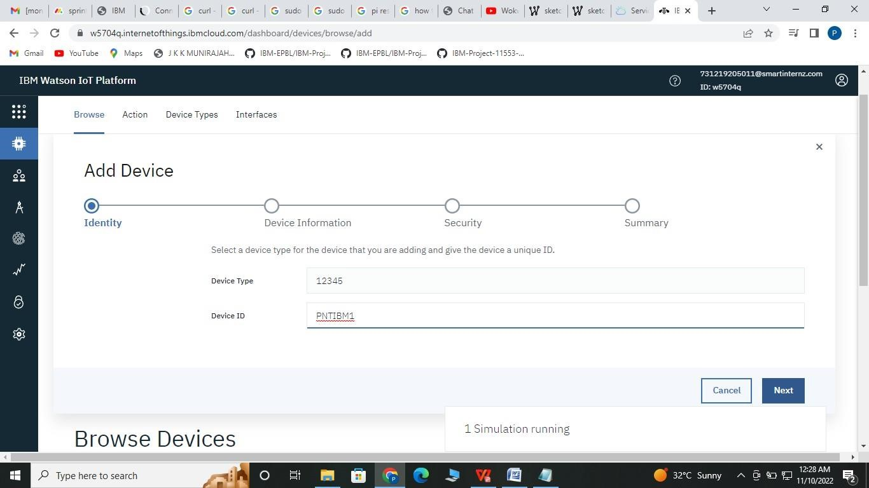

* Tick mark your device name as shown above and then click on next.
* Select the event ,property to be visualized on your graph and click next .In my case it is humidity



* Then select the size of the graph and color of the graph board you want and click next

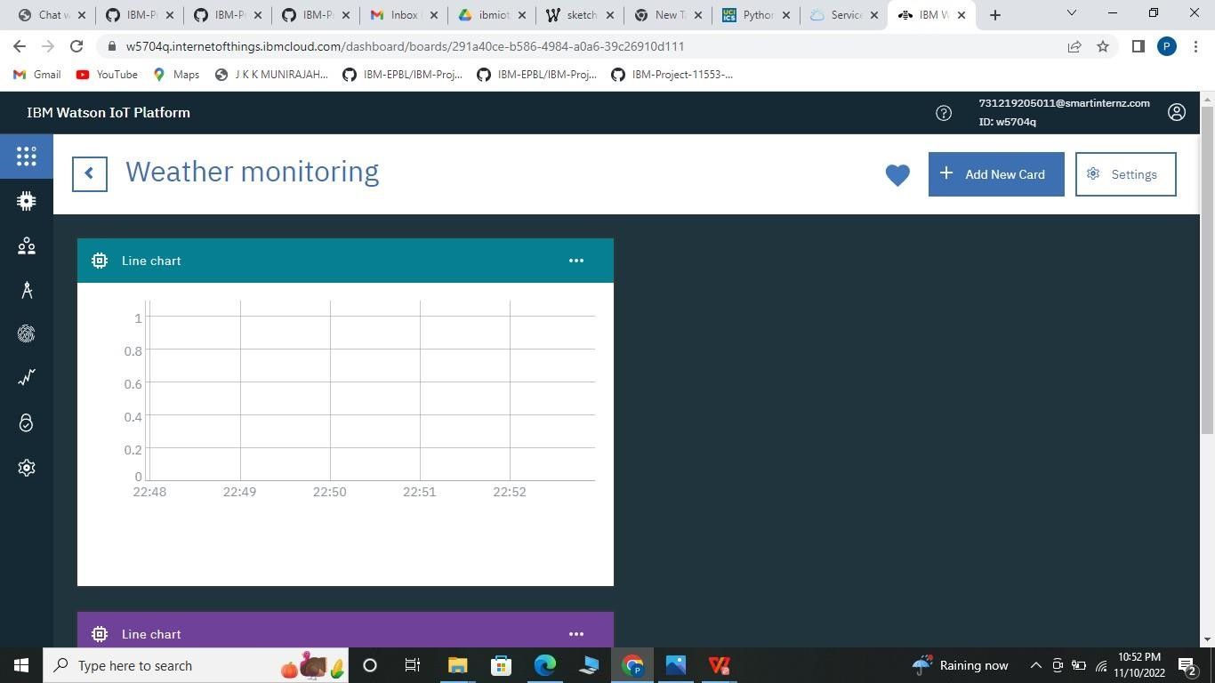

* You get your desired data in the form of a graph as shown below



**Conclusion:** Hence, we were able to send data from our pi to IBM Watson and visualize it on a graph